***Name : Shreyas Rathod***

***Collage Name: Thakur Collage of Engineering and Technology***

**Date: 20th March, 2021**

**Drive Link :** [**https://drive.google.com/drive/folders/1ROKZ4QbkLhnH26keXjWAjb6vNkawQqZQ?usp=sharing**](https://drive.google.com/drive/folders/1ROKZ4QbkLhnH26keXjWAjb6vNkawQqZQ?usp=sharing)

**Screenshots :**

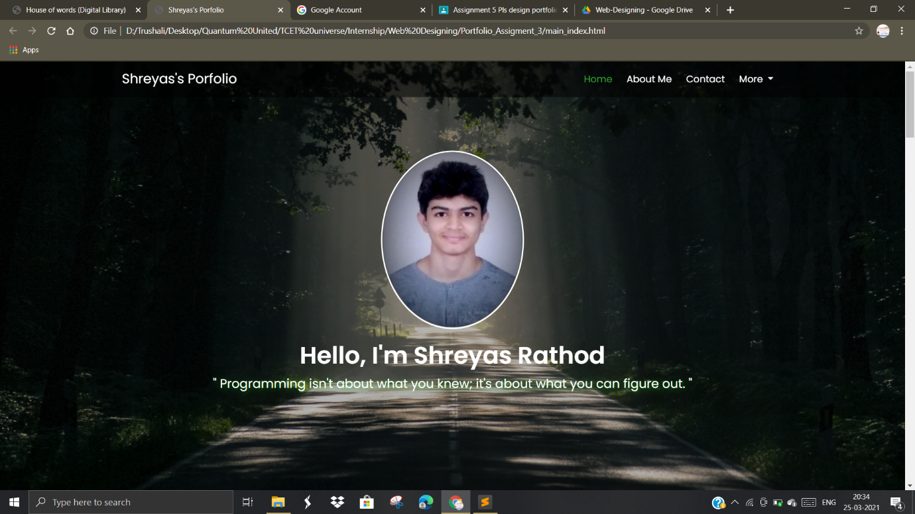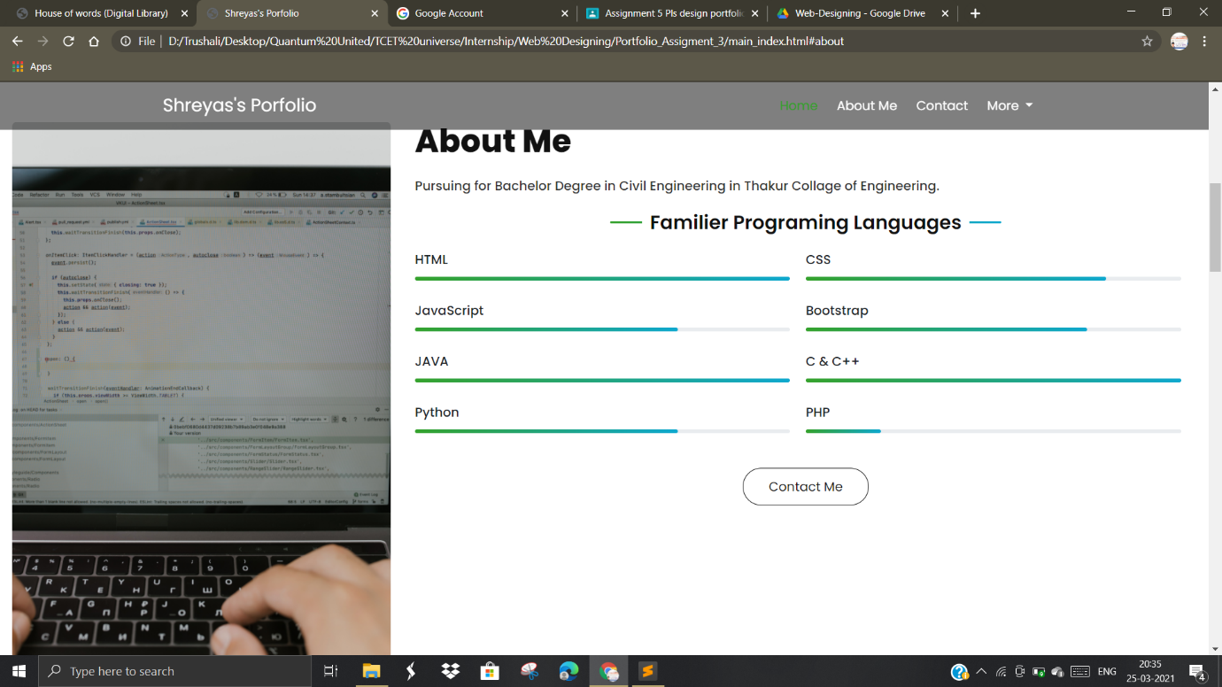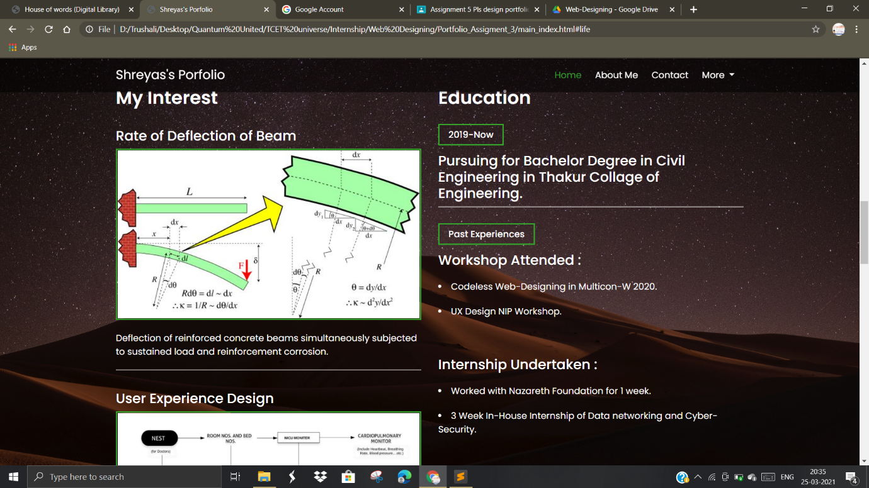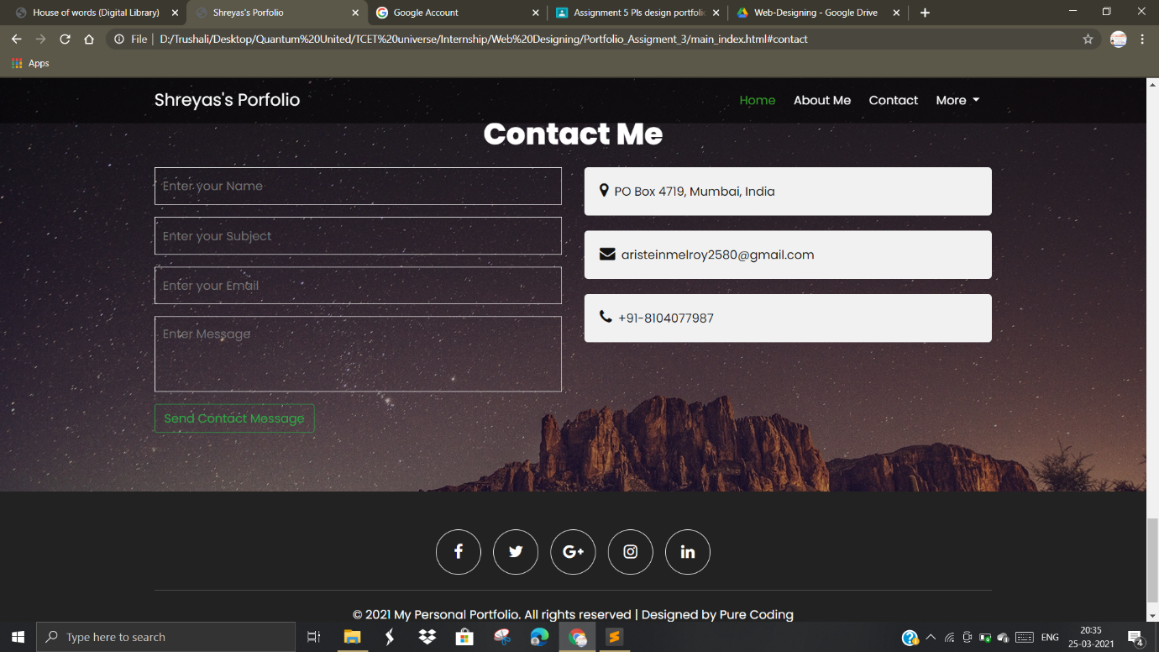

**Updates:**

1. New animations are added using HTML5 and CSS3.
2. New colour combinations are added.
3. Empty php action site added which will be updated soon in next assignment.
4. Rest of the things are exact replica of my previous assignment.